Veto Threat Bargaining With a Bicameral Congress

Scott M. Guenther
University of California, San Diego
9500 Gilman Dr. #0521, La Jolla, CA 92093
406-600-6683
sguenthe@ucsd.edu

Samuel Kernell
University of California, San Diego
9500 Gilman Dr. #0521, La Jolla, CA 92093
858-534-4988
skernell@ucsd.edu

Abstract
Prevailing theory holds that presidents’ veto threats amount to little more than ineffectual cheap talk. We argue, instead, that presidents can easily issue credible threats and frequently do. We propose a model of veto threat bargaining that re-situates the relevant transactions with Congress from the late “take it or leave it” choice to earlier in deliberations as legislators decide their collective preferences. We test this argument on the population of threatened authorization bills and a matched sample unthreatened bills from 1985 through 2008. The results are unambiguous. Veto threats sharply increase the probability that Congress modifies or removes objectionable provisions at every stage of deliberations. Moreover, the legislative process itself shifts toward a House-initiated bicameral haggling sequence. Veto threat bargaining offers presidents and Congress the wherewithal to navigate past divided government’s partisan and ideological divisions to discover new policy mutually preferred to the status quo.
In his 2015 State of the Union address President Obama set the tone of his relations with the new Republican Congress by threatening to veto five different Republican initiatives. During the first ten weeks of the new session, he followed these up with seventeen Statements of Administration Policy (SAPs) to Republican House and Senate floor leaders in which he threatened to veto legislation awaiting floor action. Obama may have gotten off to a faster start than his predecessors in threatening the new opposition Congress, but as shown in Figure 1, presidents’ reliance on veto rhetoric has become commonplace.
[Figure 1 here]
Also evident in Figure 1, the heavy use of veto rhetoric has not ramped up vetoes. Except for G.H.W. Bush during the 99th and 100th Congresses (1989-1992), presidents have averaged about a dozen vetoes each Congress. Why recent presidents have issued so many veto threats and yet relatively few actual vetoes is a question that motivated our inquiry. Perhaps veto threats elicit the desired policy concessions from Congress, rendering vetoes unnecessary. Or perhaps the prospect of a veto suffices to kill targeted legislation. Either way, veto rhetoric would offer presidents an effective instrument for warding off objectionable policies from an opposition Congress.
The frequencies in Figure 1 are also consistent, however, with less salutary scenarios for presidential power. Presidents may issue veto threats merely to curry favor with special constituencies opposed to a bill before eventually caving in and signing it. Or they may threaten unpopular legislation in anticipation that it will eventually fail and provide them a chance to claim credit for its defeat. So, the plethora of veto threats combined with the relative paucity of actual vetoes in themselves tell us almost nothing about the influence of veto rhetoric on legislation.
The fundamental problem with veto rhetoric concerns its credibility. If presidents can say one thing and do another, what, if anything, can legislators learn from presidents’ messages as they draft legislation? The prevailing answer from political science is, very little. This “cheap talk” problem has led scholars to suggest ways – in some cases, involving extraordinary effort – presidents might increase their credibility and hence the impact of their threats. We argue that these concerns are over blown. Modern presidents routinely send legislators credible signals about their preferences and likely reactions to pending legislation. These signals allow these politicians to bargain with each other across the institutional and partisan divides. The real question, we argue, is not whether presidents can credibly communicate with Congress, but rather having done so, whether this information influences congressional deliberations and the policy content of legislation.
After considering and dismissing the cheap talk issue in the next section, we propose in Section III a model of veto threat bargaining between presidents and opposition-party legislators in control of one or both chambers of Congress. Such a model must take into account both party competition and those institutional features that expose or insulate a chamber from veto threats. To test the model’s predictions, we introduce in Section IV the legislative histories of all 164 enrolled authorization bills that presidents had threatened to veto in a SAP during the years 1985 through 2008. Furthermore, to test the impact of veto threats on the substance of legislation we separately track the survival of the 876 initially introduced provisions to which presidents specifically took exception in their veto threat. The statistical relationships reported in Section V broadly confirm the pervasive impact of veto rhetoric – and hence, presidential influence – on both process and on policy.

II. Veto Rhetoric: Cheap Talk Or Credible Threat?
Despite modern presidents’ heavy reliance on veto rhetoric, prevailing political science theory largely dismisses it as ineffective. Veto rhetoric suffers from a couple of serious limitations. First and foremost, presidents cannot effectively communicate their preferences via veto threats. Second, even if they could, Congress can still play the ultimatum game – presenting presidents with policies they barely prefer to the status quo. Taken together, they portray presidents as futilely engaging in cheap talk as they try to talk their way out of their “take it or leave it” dilemma. If presidents were able to issue credible threats, both problems, we argue, would largely disappear. Presidents could then insert their preferences into developing legislation as if they were (singularly resourceful) legislators.

Cheap Talk, the Limits of Rhetoric
The fundamental problem with veto rhetoric, according to cheap talk, is that presidents can only send uninformative messages, messages that prudent legislators cannot take seriously even were they eager to learn the president’s policy preferences (Matthews 1985; Cameron 2000; Cameron and McCarty 2004). Unlike actual vetoes, executive agreements or executive orders, veto rhetoric does not commit presidents to a particular action. Presidents can threaten a bill one day and sign it the next. With presidents unable to communicate with Congress except by their actions, cheap talk abets gridlock by severely limiting the capacity of these institutions to coordinate on mutually acceptable policy.
The “veto threats as cheap talk” argument rests on assumptions that conform to the requirements of the generic cheap talk model in economics, where it has been employed to address a broad array of asymmetric information settings (Crawford and Sobel 1982). Yet applying it to veto threats requires unsupportable, herculean assumptions about presidential-congressional relations. First, a veto threat must occur in a non-repeated game. Otherwise reputational considerations would constrain presidents to send credible signals, which legislators would recognize as such. Similarly, cheap talk involves a private communication between sender and receiver. If others – say voters! – observed the transaction, they might punish presidents who shied away from their threat commitments. As with reputation, the presence of audience cost would constrain presidents to send credible threat signals. Hence, for presidential communications to qualify as cheap talk, both reputational and audience costs must be off the table. But as Neustadt (1961) observed over half a century ago, these considerations are almost always on the table.
Cheap talk’s limits on presidential influence have led scholars to consider alternative means of persuasion. One is a veto, an intrinsically costly commitment which signals a president’s clear preference for the status quo over Congress’ proposal. Cameron (2000) introduces “sequential veto bargaining” as a strategy these politicians employ to overcome their severe limitations in coordinating policy. Although highly risky, in that it involves legislating across Congresses, Cameron finds evidence that vetoes frequently precede ultimate passage of major legislation during periods of divided government.
Others have tackled the cheap talk problem directly by devising ways presidents can bolster the credibility of their rhetoric. They might introduce steep audience costs by issuing highly public, uncompromising declarations that Congress must follow or face a veto (Ingberman and Yao 1991). The downside risk of a “nuking” commitment is evident. Congress might offer a compromise that is relatively more attractive than the status quo to the public and even to the locked-in president. By committing to veto all less than “perfect” bills, presidents would find themselves forfeiting policy gains at the same time they are alienating segments of the interested public.
We argue that presidents need not engage in such extraordinary efforts to gain credibility. Opportunities for sending costly, hence credible, threats abound. (One needs to look no further than the hundreds of veto threats a newspaper reporter tallied for his readers in Figure 1.) Every message to Congress that the public and fellow Washingtonians observe has a cost term attached to it. Indeed, credible communication is essential to negotiations between the branches. Not surprisingly, credible messages flow continuously up and down Pennsylvania Avenue.

Credible Threats, a Game Changer
But credibility solves only the first of the two problems. Presidents still face another formidable barrier that resides with the veto itself. However informative their threat may be, they will still face a “take it or leave it” choice. Although credible threats should lead to legislation that more accurately identifies presidents’ indifference point -- hence, fewer vetoes – Congress retains the upper hand in fashioning legislation that allows it to capture any policy surplus. Consequently, credible threats can only partially rescue presidents from the veto’s ultimatum bind. They still find themselves signing bills they barely prefer to the status quo. If credible veto threats are to give presidents real clout, they must pry open deliberations and allow presidents to insert their policy preferences as legislation is still forming. Below we find that they do.
For the most part, the literature on presidential vetoes and veto threats follows a standard separation-of-powers script. Congress presents enrolled bills to presidents who sign or veto them. How these bills are arrived at – whether through an easy consensus or from a legislative brawl – does not matter. Congress presents presidents with a single alternative to the status quo. Yet for presidents able to issue credible threats during congressional deliberations, the separation-of-powers model short-sells presidents’ potential influence. If veto threats prompt legislators to look down the decision tree and reassess the likelihood of the president signing or vetoing each of the alternative bills under consideration, they may switch their support from the bill conferring the greatest policy gains to one that stands a better chance of enactment (Martin 2001). If veto threats cause legislators to make these calculations early, presidents may succeed in shaping policy to a much greater extent than envisioned by the separation of powers framework.
Consider the following scenario: A president observes an unacceptable bill comprised of the following provisions {~w,x,y,z}. He most favors {w,x,y,~z} and would accept {~w,x,y,~z} over the status quo. What does the president do? He might threaten any bill that excludes w and includes z. Those legislators championing policies x and y may find their enthusiasm for z waning, especially if w’s ardent supporters are equally numerous. Or they might counter with an offer that includes both w and z.
The potential effect of veto rhetoric extends beyond tweaking individual legislators’ utility assessments of alternative legislative bundles. Partisan considerations and institutional biases may mediate the impact of a veto threat at each stage of the process. They may determine whether its impact will be substantial or nil. Legislators and presidents are members of party teams. Each team’s success and failure in the legislative arena might contribute to its reputation and consequently, to each team member’s reelection prospects. Presidents join deliberations not as outsiders but as singularly resourceful members of their party team. Furthermore, a chamber’s non-majoritarian rules, procedures and allocations of authority may bias legislation in favor of one of the party’s policy preferences. Median House and Senate members might hold identical preferences, and yet their chambers adopt quite different bundles of provisions. Veto rhetoric acts not just on members’ individual preferences but also on the sequence of decisions that constitute the legislative process.

III. The Institutional Context of Veto Threat Bargaining
The Constitution enfranchises the House of Representatives, the Senate and the presidency with a veto over legislation. The Constitution further provides for only one override, requiring the other two veto players, the House of Representatives and the Senate, to repass a vetoed bill with two-thirds majorities in each chamber. Moreover, with few exceptions, the Constitution leaves it to each chamber to legislate according to its own devised rules. Since the early days of the Republic the House and Senate have taken different paths to collective decision making (Wirls and Wirls 2004; Schickler 2001). These modern institutions have evolved distinctly different rules and procedures such that as partisanship has become more polarized, it has strengthened House leaders while weakening control of their Senate counterparts. Multiple layers of delegation, agenda control, voting rules and internal veto points create numerous nodes on the decision tree where some members and their preferred policy enjoy an advantage. As legislative leaders look down the decision tree to anticipate the actions of the other veto actors who will subsequently take their turn with the bill, they might elect to reroute the legislative process in order to preserve their advantage or to avoid late setbacks that could kill the bill. We are describing the standard legislative practices, but with a twist: by strategically inserting veto threats into deliberations, presidents may be able to influence how legislative leaders structure deliberations.
Into this institutional setting we must also fully incorporate partisanship. For most of its history legislators and presidents have affiliated with one of the two major political parties. A party’s congressional performance may burnish or tarnish its brand reputation with voters. Similarly, presidents’ promises and performance serve as focal points with which voters appraise the presidential party’s brand as they decide between congressional candidates (Jacobson 2015). This motivates the president’s co-partisans to support the administration program while reinforcing the opposition party’s efforts to defeat it. “Regardless of their [legislators’] views on the policy merits of a presidential initiative,” concludes Lee (2008: 914), “how they handle a president’s priorities will affect his party’s collective reputation. Presidential successes create credit-claiming opportunities for the president’s party.” When presidents publicly threaten to veto a bill – particularly, on policies with which the parties publicly disagree – they are putting their party’s brand reputation on the line. As a result, some number of the president’s partisans will, if necessary, alter their stance on legislation in order to contribute to the president’s success. Congressional leaders, allied with the president, will seek to rein in wayward legislators to back the president. They may even ask the president to up the ante by delivering (or repeating) a public veto threat. Opposition partisans, conversely, will look for ways to defeat and embarrass the other party’s presidents, and by association their co-partisans in Congress (Groseclose and McCarty 1997). Consequently, when presidents stake out clear positions, party preferences in Congress tend to separate and harden (Fett 1992 and 1994; Lee 2008).
To summarize, veto threat bargaining has legislators (including presidents) pursuing policy provisions according to their diverse constituent interests and shared party stakes. They assemble these preferences into bundles of discrete (sometimes, disparate) policy provisions according to the dictates of each veto actor. A credible veto threat sets into motion a bargaining game among the partisan teams that control these several institutions. We turn now to the implications of this general model for the impact of veto threats in the specific context of the modern bicameral Congress.

House of Representatives and the Senate
With the House of Representatives organized to secure the majority party caucus’s preferences (Cox and McCubbins 1993; Rohde 1991) and block minority party initiatives (Cox and McCubbins 2005), the president’s co-partisans have little, if any, opportunity to remove threatened provisions. Cox and McCubbins (1993:122) argue that the majority party administers the House of Representatives’ agenda in part to frustrate opposition presidents and shift the “partisan electoral tides” in the next election. The majority party controls numerous advantages in delegating discretionary authority and controlling the legislative agenda. One of more determinative and visible instruments of majority party is control of the Rules Committee, which sets the terms of a bill’s consideration on the chamber floor, including whether and which amendments may be offered. In prediction IA we test the expectation that an opposition-controlled House will resist veto threats. The Rules Committee is more likely to attach to threatened bills restrictive or closed rules, making it difficult for the president’s partisans to remove objectionable provisions.
1A: The House Rules Committee responds to veto threats by adding closed and restrictive rules.
The Senate’s institutional arrangements are much different. Individual members retain extensive prerogatives, such as unbridled access to the chamber’s floor. This in turn opens the door to modern filibuster practices which the president’s co-partisans may be quick to invoke against an opposition controlled chamber (1B). Raising the bar for passing threatened bills from 51 percent of those voting to 60 percent of the membership will normally require Senate leaders to accommodate the president’s allies (or abandon the bill) to a greater extent than House leaders. The highly divergent implications of these chamber’s institutional arrangements suggest that presidents will enjoy greater success in extracting objectionable provision in the Senate than the House of Representatives (1C).
1B: Veto threats trigger filibuster threats.

1C: The Senate will be more responsive to veto threats than the House of Representatives in removing or modifying objectionable provisions.

Veto Threat Bargaining As a Haggle

The House’s and Senate’s institutional practices are long-standing and predictable. This allows legislators to anticipate the chambers’ and the president’s preferences as they plan their legislative calendars. Here, we ask, might these anticipated responses veer veto threat bargaining down a different path – specifically, a legislative sequence designed to timely elicit presidents’ objections and give Congress an opportunity to discover a legislative bundle acceptable to each veto player? The particular legislative sequence we have in mind takes the form of a haggling negotiation. The chamber holding extreme preferences bids first, drawing out the president’s objections. Once the extreme preferences are on the table, legislative deliberations can proceed as a haggling negotiation as the several sides converge toward a more moderate, mutually acceptable policy, if one exists (Cameron and McCarty 2004).
Taylor (2009) develops this intuition into a model which has House and Senate leaders coordinating the sequence of deliberation so that the chamber that is more ideologically distant from the president opens bidding with its preferred bill. Analyzing legislative sequences for nearly a thousand bills from 1955 through 2002, he finds that when the opposition controlled both chambers, the more ideologically distant chamber, as measured by median members’ DW-Nominate ratings, initiated significantly more bills than did its more moderate counterpart. Following this logic, prediction 2A hypothesizes that presidents will concentrate their threats on the provisions of the first-mover’s bill.
If such a haggle is to succeed in creating a new law, the next consequential move will likely involve some modification of the initial proposal that brings the bill closer to the president’s preferences. Since presidents issue many of their threats as the first chamber takes up the issue for floor consideration, we have in Figure 2 distinguished the chamber’s proposing action (e.g. a committee report) from its final floor action. Consequently, the second move can be made by either the first-moving, more extreme chamber or by the more moderate chamber. For a variety of reasons, we should fall more easily on the second chamber. There are several reasons for expecting the second chamber to take the next step in the haggle. First, it presumably holds more moderate policy, making it easier to modify the extreme bill’s objectionable provisions. Second, by standing steadfast in support of its initial proposal, the first chamber preserves the credibility of future initiatives. (Allowing reputational considerations to underwrite veto threat bargaining not only gives presidents the ability to send credible signals, it contributes here to the sequence with which policy differences are resolved.) Finally, the first chamber retains a veto over the final, conference report. To capture this sequence, prediction 2B has the second chamber modify threatened legislation. We refer to this three-stage sequence as a Bicameral Haggle.
[Figure 2 here]
We have already identified those features of the House of Representatives (aka “legislative leviathan”) that suit it well to propose extreme bills. Its majority exerts stronger control of the chamber’s decisions – allowing it to pass policies closer to those preferred by the majority caucus’s median member and more distant from the opposition-controlled White House. According to these textbook features we should expect to find the House initiating a disproportionate share of “extreme” bills and consequently, presidents disproportionately targeting House proposals with veto threats (2C).
The House’s enthusiasm for an extreme policy is complemented by the Senate’s moderation giving it a comparative advantage in fashioning compromises. One needs to look no further than the filibuster to appreciate the influence available to the president’s minority-party allies, as long as they can muster 41 votes. Accordingly, in 2D the House will take the lead in proposing extreme policy and threatened with a veto, the Senate the lead in moderating the legislation. We consider other haggling sequences below, but none enjoys the same compelling logic as this House-initiated Bicameral Haggle.
The first chamber could, and occasionally does, modify objectionable provisions before passing and sending the bill to the second chamber. In the figure, we label this as a Same Chamber Haggle with the president. Although the second chamber’s moderating role might appear obvious, and even necessary, it is not. These legislators might defer consideration of a veto threat until conference. This is represented as the Stonewall path in Figure 2. It would eliminate a critical, step-wise convergence of haggling and return the legislative process to separation-of-power’s “take it or leave it” choice.
2A: Veto threatened provisions are more likely to be introduced in the initial proposal than subsequently.

2B: The second chamber will modify the first chamber’s threatened provisions, producing a Bicameral Haggle.

2C: The House of Representatives’ proposals are more likely to attract a veto threat than the Senate’s.

2D: Given the institutional differences between the House and Senate, veto threatened provisions will follow a House-initiated Bicameral Haggle.

Conference Committee
Conference represents a critical juncture in discovering policy that each chamber’s pivotal member and the president prefer to the status quo. Conferees must find a bill that a majority in each chamber will agree to, as well as one that the president will likely sign. To minimize miscalculation, conferees routinely solicit the views of the president’s representatives, even inviting them into deliberations (Longley and Oleszek 1988). As conference searches for mutually acceptable policy, 3A predicts that it will favor available moderation of veto threatened provisions. This might involve conferees simply ratifying compromises the House and Senate have already struck (same chamber and bicameral haggles), resolving disagreements between the chambers (same chamber reversals) or even perhaps moderating provisions the chambers had previously stonewalled.
3A: Conference will be more likely to modify (and preserve previous modifications to) veto threatened than unthreatened provisions.

IV. Data and Method
Both former White House aides and internal memoranda archived at presidential libraries tell a story of administration representatives continuously communicating the president’s views on legislation pending before Congress. White House legislative affairs teams spend much of the workday on the Hill privately plying individual legislators. These and numerous other private efforts are certainly less costly, and less credible, than public veto threats. The latter class includes a variety of activities spanning a broad spectrum of publicness from the president’s nationally televised annual state of the union address to congressional testimony during which an administration official avers the prospect of a proposed provision triggering a veto threat. Figure 1 shows that the volume of veto threats contained in president’s Statements of Administration Policy, or SAP, have become a favorite medium for presidents to threaten bills pouring out of opposition-controlled Congresses.

Treatment Variable: Veto Threats in Statements of Administration Policy (SAPs)
Introduced in 1985 at the initiative of OMB Director David Stockman, SAPs formalize under an OMB letterhead the memoranda White Houses had in the past informally sent Congress stating the president’s position on pending legislation. With few exceptions SAPs provide legislators with detailed information about presidents’ objections to current proposals. Frequently, presidents go beyond simply calling for removal of objectionable provisions by offering alternative policy that would win their endorsement. A valuable feature is these memos both for legislators and scholars, SAPs distinguish several levels of commitment to the president’s opposition to a pending bill. Only about twelve percent of the veto threats in SAPs declare presidents’ unequivocal commitment to veto a bill that fails to address their objections. These take a form of the first person declaration: “I will veto …” and “The president will [or ‘will have to’ or ‘would have to’] veto the bill ….” The vast majority of threats afford presidents wiggle room (Schelling 1980) by being less emphatic or attributing to others the likelihood of veto. In these cases, the SAP refers to “senior advisors” or some cabinet official will “recommend that the president veto….” The fact that for the past three decades administrations have, under the guidance of OMB, employed nearly identical threat language reduces the risk that legislators will parse the president’s signal incorrectly.
Frequently, the White House issues a SAP less to reveal novel information about a president’s preferences than to strengthen the signal of his or her commitment to the veto. The head of President Clinton’s White House legislative affairs office offered an incident in 2005 as indicative of this purpose: “We told them [Republican members of Congress] what the president needs on a bill but they’d ignore us. Then when the president issued a SAP, Republican leaders squawked that they had been blindsided. But it forced them to pay attention to the president.”
Apparently from the outset OMB distributed SAPs widely, well beyond the floor leaders to whom they were addressed. (Since 1997 OMB has posted all SAPs on the White House website.) When issuing SAPs, presidents can be sure that all relevant parties in Washington and interested constituencies across the nation will soon learn the administration’s position on a pending bill. In fact, until recently, when Kernell (2005) discovered a possibly exhaustive set of SAPs containing veto threats in a private collection, the only “interested” professionals unaware of these memoranda appear to have been political scientists. Our ignorance may be attributable in part to these memoranda’s semi-official status. Unlike veto statements and other official presidential documents, SAPs have never been systematically logged and archived.
Over the twenty-four year period ending in 2008, presidents issued SAPs threatening to veto 627 authorization bills. Of these, 463 faltered in Congress. Although the attrition rate may appear high, it is comparable to unthreatened bills reported out of committee calculated from the Congressional Bills Dataset (Adler and Wilkerson 2006). In order to understand how veto threats help presidents shape legislation that they will eventually be required to sign or veto, we have limited the analysis to the 164 threatened and enrolled bills along with their unthreatened matched counterparts.
All but a few of the threatening SAPs contain specific objections to the legislation as the basis of a possible veto. Altogether, the SAPs for enrolled bills target 876 provisions, which we separately track through the legislative process. Table 1 provides three veto threat excerpts from SAPs and the corresponding legislative text triggering the threat to illustrate the process of translating the veto rhetoric from SAP to bill provisions. Over the course of deliberation, Congress either dropped or significantly modified nearly three-fifths of the objectionable provisions to bring them closer to the president’s preferences. Presidents did sign 26 bills in which Congress failed to remove or modify any targeted provisions, but all but two had passed both chambers with veto proof majorities.
[Table 1 here]

Method
With some of the above predictions addressing the legislative process and others dealing with the policy content of legislation, we developed bill and provision level datasets for the analysis. In each case, the predictions of the model require testing a veto threat’s impact against a control population of unthreatened observations. We enlisted clustered random sampling to populate the control population of unthreatened provisions for the provision-level dataset. The cluster sampling procedure allows us to more finely parse the trajectory of unthreatened provisions and the relevant bill-level covariates than tracking a random set of provisions across many disparate bills would allow. In total the sampling procedure produced a control sample of 568 unthreatened provisions. Within the random sample of provisions sixteen were among those subject to a SAP veto threat. Setting these aside, the combined total population of threatened and unthreatened provisions was 1,420, which comprise our core provision-level dataset. The sixteen overlapping cases, however, also allow us to estimate an incidence rate for veto threats and correspondingly weight the data to correct for the oversample of threatened provisions using a choice-based sampling weighting procedure (see Manski and Lerman 1977; Cameron and Trevedi 2005; Cameron 2000).
To estimate the causal effect of veto threats on provisions more precisely we further refine the random sample of unthreatened provisions using a genetic matching algorithm in the R statistical package MatchIt (see Ho et al. 2007; Diamond and Sekhon 2012). The genetic matching algorithm takes the random sample of provisions and iteratively weights the observations to maximize balance on the specified observable covariates (Sekhon and Mebane 1998). Like other forms of matching, the genetic algorithm winnows out control provisions dissimilar to veto threatened cases, leaving the provisions most similar to the population of threatened provisions. For testing those hypotheses about the legislative process, we run the same genetic matching algorithm on the full population of enrolled bills from 1985 to 2008. The larger pool of observations allows for an increase in the number of control observations from 1:1 for provision level dataset to 3:1 for the bill level dataset, improving the balance of threatened and unthreatened cases on the observable covariates.
These procedures provide three distinct datasets: 1) bill-level observations winnowed by genetic matching to yield comparable populations of unthreatened and threatened enrolled bills; 2) the choice-based sample comprised of all threatened and a random sample of all provisions, weighted to correct the over-sampling of threatened provisions; and 3) genetically matched provision-level data for assessing the treatment effects of veto threats on a provision’s survival or modification. All of the dependent variables are binary which we estimate with logistic regression; the provision-level estimates are clustered by bill to adjust the standard errors.

Systematic Sources of Veto Threats
Threats do not arise randomly. Nor, as we show below, are they the endogenous products of presidents cherry picking doomed bills and provisions in order to claim credit for their defeat. Rather presidents rely on veto threats during divided government to fend off and temper major legislation from opposition controlled Congresses. To better appreciate the antecedents of veto threats, the model in Table 2 estimates the probability of a veto threat as a function of divided party control and other familiar covariates of research into presidential-congressional relations for several levels of observation: all bills, bills reported out of committee and provisions sampled from enrolled legislation. Bills introduced by committee chairs, requested by an administrative agency, or sponsored by a large number of cosponsors all increase the likelihood of a veto threat. A consistent pattern emerges from these relationships of presidents threatening important bills that may well show up on their desk as enrolled bills.
[Table 2 here]
As expected, opposition control of the House and Senate significantly increase the likelihood of a bill being threatened by five and three percentage points, respectively (see equation 2). Presidents, however, appear to enjoy a legislative honeymoon during their first year of office, in that they are significantly less likely to issue veto threats. For enrolled provisions in equation 3 majority party and committee chair status for the bill’s author lose significance. Though these variables predict legislative advancement in equations 1 and 2, they offer little to distinguish the legislative vehicles for multiple threatened provisions from other bills eventually enrolled.
In targeting bills they judge likely to become enrolled, presidents seek a more palatable choice later. Drawing on the specification in Equation 1, Table 2, we test for the presence of endogenous veto threats by specifying an instrumental variable probit model. The possible presence of endogenous regressor poses a serious issue in that presidents are sophisticated actors who might be tempted to threaten bills likely to fail in order to claim credit for their demise. Following Newey (1987) a Wald test of exogeneity does not reject the null hypothesis that threat selection is exogenous. (For the full results of this analysis, see the supplementary materials.)

V. Findings
The findings confirm the predictions that veto threat bargaining substantially shapes both the content of legislation and the process that produces it. The chambers’ dissimilar levels of control over floor proceedings are key for accounting for the impact of veto threats at each stage of deliberations. As legislators and presidents anticipate the chambers’ likely actions on a bill, they may reroute deliberations of veto threatened bills down distinct legislative paths we refer to as haggles.

House of Representatives
1A: The House Rules Committee responds to veto threats by adding closed and restrictive rules.
Among other things, a House rule sets the allowable number and substance of floor amendments. Closed and restrictive rules are arguably the strongest tool available to the House majority to protect its policies from being rolled by the opposition (Cox and McCubbins 2005; Monroe and Robinson 2008). As a result, the rule attached to a veto threatened bill strike at the heart of a president’s ability to pry concessions on the floor.
Over the years the House Rules Committee’s definition of its classification of its rules has changed – the tighter they have become, the looser they appear. Fortunately, Owens and his colleagues (Owens and Wrighton 2007) have reclassified many of the bills analyzed here using a standardized classification system. We employ their data where available and apply their six-category definition to classify more recent rules resolutions. The distribution of rule types for threatened and unthreatened legislation in Figure 3 clearly supports 1A’s prediction that veto threats prompt opposition majorities to tighten control over floor action.
[Figure 3 here]
In a preliminary analysis (reported in the supplementary materials), we determined that little information is lost by collapsing the six categories into a binary variable that distinguishes those rules that either outright prohibit or severely restrict the ability to modify legislation through floor amendments versus all other rules (and the absence of a rule). The statistical relationships in equations 1-3 of Table 3 demonstrate that the House is more likely to bring legislation to the floor under a restrictive rule when the president has issued a veto threat. Whether examining all enrolled bills (equation 1) or the matched sample (equation 2), the House appears to curb presidents’ efforts (via their legislative allies’) to moderate threatened provisions on the chamber floor.
Adding a dummy variable (equation 3) to indicate those bills for which the president issued an unequivocal “will veto” appears to prompt the House to increase the likelihood of cutting off floor amendments. The effect is best illustrated in Figure 4A, which converts the coefficients in Table 3, equation 3 into marginal probabilities. A veto threat increases by 60 percentage points the probability that the bill will go to the floor with a closed or restrictive rule; the marginal effects show a near universal response to a “will veto” threat with restrictive rules. The posturing of these opposing veto actors appears to set the legislation on a course of deadlock, and yet all of these bills eventually become enrolled and the majority signed into law.
[Table 3 and Figure 4 here]

Senate

1B: Veto threats trigger filibuster threats.

Whereas the House effectively restricts floor access to threatened legislation, the filibuster rule in the Senate gives all members access to propose amendments on the chamber floor. When presidents coordinate their threats with their Senate partisans, the Senate floor becomes the most attractive point in the legislative process for the White House to extract concessions from an opposition Congress. Prediction 1B argues that such party coordination is present: veto threats lead fellow partisans to issue filibuster threats. Testing this simple proposition proved tricky, largely because the minority party no longer has to physically engage in extended debate to stymie Senate action. All its leaders need to do is announce that they will filibuster a bill if certain provisions are not dropped. Consequently, the efficacy of behind the scenes filibuster threats make this critical feature of Senate deliberations notoriously difficult to measure. After testing several different specifications commonly found in the literature, we settled on Sinclair’s (2011) coding procedure for scoring those filibuster threats referenced in Congressional Quarterly’s Weekly Report and Almanacs.
The results in equations 4 and 5 of Table 3 uniformly confirm hypothesis 1B. For both all enrolled bills and our matched sample, those bills containing threatened provisions are significantly more likely to attract a filibuster threat. A veto threat increases the marginal likelihood of a filibuster by roughly 25 and 22 percentage points in equations 4 and 5, respectively. The impact of the stronger “will veto” threat language for House rules does not appear (see Figure 4B) to increase the likelihood of filibuster threats (equation 6).
1C: The Senate will be more responsive to veto threats than the House of Representatives in removing or modifying objectionable provisions.
One reaction to a looming filibuster threat is inaction. Filibuster threats may stymie legislation either by revealing the absence of a mutually preferred policy or by adding steep transaction costs to future deliberations. For those bills that do survive and reach enrollment, however, the Senate is more responsive to veto threats in revising provisions whether they originate in the House or Senate. This is the principal finding of the models estimated in Table 4 and the derived probabilities plotted in Figure 5. The Senate’s rate of removing or modifying a threatened provision in its or a House bill is 35 and 55 percent, respectively. This compares to 26 and 46 percent of threatened provisions modified by the House when acting first and second. It is important to bear in mind, however, that these differences are marginal, and stand in stark contrast to the low modification rates of matched unthreatened provisions.
[Table 4 and Figure 5 here]

Haggling
2A: Extreme provisions provoking veto threats are more likely to appear in the initial proposals than in subsequent revisions.

2B: Holding more moderate preferences, the second chamber will modify the first chamber’s bill to accommodate veto threats. The resulting sequence constitutes a bicameral haggle.

2C: A bill initiated by the House of Representatives is more likely to attract a veto threat than is a Senate bill.

2D: The institutional differences between the House and Senate suggest that veto threats will induce a House-initiated bicameral haggle.

Consistent with prediction 2A, only three of the 164 legislative histories of enrolled bills found presidents initially tendering their veto threat only after the second chamber took up the bill. Whether this early exchange of incompatible preferences blossoms into a full-fledged haggle depends on the next mover’s response. This may take the form of a bicameral or a same chamber haggle (see Figure 2). Legislators in the originating, extreme chamber may anticipate the actions of the more moderate chamber and prudently decide to husband their bargaining chits until conference. Hence, 2B predicts that the task of fashioning a compromise from these early bids will fall principally on the second chamber. In Figure 5 the probability of the House or the Senate dropping or modifying a threatened provision increases sharply whenever it acts second. The 45 percent and 53 percent revision rates for the House and Senate when acting second are all the more impressive since they are based only on those threatened provisions that the first chamber failed to drop or revise.
With the House majority party able to exercise greater control than its Senate counterpart over floor decisions, 2C predicts that House proposals will be more likely to attract veto threats. We have already reported clear evidence of this bias in Table 1 where the variable designating bills and provisions originating in the House of Representatives is closely associated with the president’s selection of legislation to threaten. Presidents are 1.66 times more likely to target a House proposal. Combined with the House’s greater productivity, presidents find themselves sending about 80 percent of their threatening SAPs to House leaders. This sets the stage for the House-initiated bicameral haggle hypothesized in 2D. In Figure 5 the probability that the Senate will modify a provision increases sharply once it has been threatened. Overall, sixty percent of veto threatened House provisions fail to make it out of the Senate. Of the various combinations of chamber responses diagrammed in Figure 2, the House-initiated bicameral haggle represents the modal sequence, occurring for fully a third of all provisions that presidents threaten. It is about eight times more likely to occur than the reverse bicameral sequence that has the House modifying threatened Senate provisions.
Nonetheless, presidents do threaten Senate bills. This raises the question, do veto threats directed at the Senate similarly launch haggling sequences? The answer is that they largely do – 49 percent of Senate-initiated provisions compared to 53 percent for the House. But here the similarity ends. Veto threatened Senate proposals are much more likely to follow the same chamber than the bicameral sequence, while the reverse pattern characterizes haggles of House proposals. Of the threatened provisions that follow a haggling sequence, only 44 percent of those originating in the Senate take a bicameral haggle trajectory compared to 71 percent of House provisions. This pattern is fully consistent with the textbook representations of these chambers. The House sticks to its extreme proposal most of the time, whereas the filibuster forces a Senate retreat before the bill leaves the chamber. Yet neither chamber wholly conforms to this stereotype. When the Senate fails to modify a threatened provision, there is a 50-50 chance that the House will do so. With the Senate frequently modifying its proposals on the floor after a veto threat, however, the House is infrequently called upon to accommodate the president.
Although legislative sequences for unthreatened provisions are more ambiguous given the absence of the directional dimension supplied by a president’s veto threat, comparing instances where threats are present and absent are informative. If, as we argue, the frequency of different haggling sequences reflects the distance in the policy preferences between presidents and opposition-party majorities in the House and Senate, then sequences should be less prevalent for unthreatened bills. In the raw distributions underlying the probabilities shown in Figure 5, significantly fewer unthreatened provisions (44 percent to 65 percent of threatened provisions) ever see a revision of any kind. Moreover, when one chamber revises its threatened proposal on the floor the likelihood that the second chamber will revert back to the original provision is less than 2 percent, about six times less likely than reversals of veto threatened provisions.
Measured by the greater frequency with which threatened provisions are revised and reversed, veto threats appear to allow presidents to set the legislative agenda. This preoccupation with threatened provisions becomes even more apparent in conference, which is understandable given the possibility of an actual veto on the near horizon.

Conference Committee
3A: Conference will be more likely to modify (and preserve previous modifications to) veto threatened than unthreatened provisions.
Conferees do not greet each bill’s arrival as a fresh opportunity to make new policy. Instead, legislation arrives at conference laden with layers of actions and expectations from each veto actor. Conference’s formal mandate requires it to assemble a bundle of provisions that satisfy the pivotal members of the House and Senate; increasingly, conference has an additional, informal mandate of finding a bill that also satisfies the president (Sinclair 2011).
Each of the four types of legislative histories in Figure 2 presents conference with different issues to resolve. About half of the veto threatened provisions arrive with the chambers in agreement (same chamber haggles and stonewalls), but only about a tenth (second chamber reversal) find the chambers in clear disagreement. Bicameral haggle represents the largest and theoretically most interesting class of provisions for conference action. Where the second chamber’s modification is coordinated with the extreme chamber, conference simply certifies the haggling compromise. Where the second chamber’s action fails to take the first chamber’s preferences adequately into account, however, conference faces a difficult task of resolving disagreement while keeping an eye on the administration’s minimum requirements.
[Table 5 here]
Prediction 3A has conferees, ceteris paribus, opting for modified versions of threatened provisions in order to improve chances of winning the president’s signature. Testing 3A on each class of legislative sequences requires estimating complex interactions between legislative sequence and the presence of a veto threat. For ease of interpretation, Figure 6 maps the marginal effects from the logit estimates in Table 6. If conferees wholly disregard veto rhetoric, we should find that conference’s preference for a modified (or when threatened, a moderated) provision would be statistically indistinguishable for threatened and unthreatened provisions. For three of the four sequences, veto threats clearly guide conference’s choices of provisions in favor of moderation. The greatest differences between threatened and unthreatened provisions occur for bicameral haggles; conference endorses 78 percent of the second chamber’s action on threatened provisions compared to on 18 percent on unthreatened.
The single null result arises for stonewalls, where the second chamber agrees with the first chamber’s extreme proposal. One might suspect that conference would take into account the president’s pending decision and moderate many of these provisions. If a veto threat fails to move either chamber its impact in conference, we find here, is minimal. Although still significantly greater than zero, the probability of a modification is no greater than for unthreatened provisions where the chambers retained the original provision.
Our model actually has little to say for this class of legislation, since veto threat bargaining incorporates the president’s preferences in each chamber’s deliberations. The more relevant model for predicting conference action on this class of legislation is the classic separation of powers game. It has Congress discovering its collective preference and adjusting it to win the president’s signature. The absence of an impact for veto threat in shifting conference away from stonewalls suggests that conferees do not make such calculations.
Comparing modifications of threatened provisions across the legislative histories in Figure 6 is also informative. Of the four types of sequences, conference should be most likely to endorse a moderating policy when the chambers have already modified the provision in response to the threat. Indeed, in Figure 6 conference ratifies 93 percent of the same chamber haggles. When the second chamber fails to go along with the first chamber’s revision, however, conference adopts only about half the moderating provisions. This outcome is inconsistent with prediction 3A. In keeping with its mission, conference is disinclined to upset House-Senate agreement whatever their bearing on the prospects of a veto. Finally, this backdrop of endorsing consensus returns us to the 78 acceptance rate for bicameral haggles, the most populous of the sequences on threatened proposals. Entering conference the House and Senate may appear to differ, but in fact, more often than not, a deal has been struck with the White House.
[Table 6 and Figure 6 here]

Postscript: Bills Become Laws

With the arrival of an enrolled bill on the president’s desk, legislative deliberations and with them, veto threat bargaining end. Of the 876 veto threatened provisions, distributed across the 164 enrolled bills, Congress removed or significantly moderated 56 percent. Now presidents decide whether their objections have been adequately accommodated so that the final bill falls within their zone of acceptable policy? Moreover, they ponder: might they do better by vetoing the bill and awaiting a more attractive bundle of policies from the next Congress? If their first answer is no, they veto. Even if their minimal requirements are met, however, the prospect of an even better bill from the next Congress might also prompt them to veto (Cameron 2001).
Veto threat bargaining does not assure success. Presidents vetoed nearly thirty percent of the threatened bills reaching their desk. In some instances vetoes may reflect miscalculations by presidents or Congressional opposition leaders. In other cases the Congressional opposition party held veto proof majorities and could ignore both threats and vetoes. Congress overrode eight vetoes. And on 24 other veto proof bills – slightly more than half of which passed by unanimous consent during both chambers’ initial consideration – presidents appear to have thrown in the towel, signing them without compensating compromises to any of their objections.
A much greater number of the threatened bills did not command veto proof majorities, however. These required prudent opposition leaders to address some or all of the presidents’ objections. Figure 7 offers a summary accounting of the relationship between Congress’ and presidents’ actions on those bills that failed to attract veto proof majorities. Where Congress needed the presidents’ signature, it won it by addressing their objections. Presidents signed almost all (33 of 36 bills) fully accommodated bills. Conversely, they vetoed almost all in which they were stonewalled (26 of 28 bills).
[Figure 7 here]

VI. Conclusion
During periods of unified government presidents are expected to lead Congress. Once when unified government was the norm, the adage, “The president proposes, Congress disposes” pretty well described the routine relations between these branches. It fell upon presidents to identify new problems and new solutions to old problems, to persuade their party’s legislative leaders to embrace them, and whenever close votes loomed, to cultivate marginal legislators with promises and various, more tangible inducements. With the president’s initiative and energy, Congress enacted laws that reward the party’s core constituencies and established a record of accomplishment that presumably put the governing party in good stead with voters in the next election cycle.
The conventional view of relations between these branches during divided government is vastly different. Divided party control shoves presidents from center stage until a brief appearance in the last act. Presidents’ initiatives arrive at Congress “DOA” (Democratic House Ways and Means chair Dan Rostenkowski’ reference to the 1987 Reagan budget). Instead, the opposition-controlled Congress sets the policy agenda and depending on the size of its majorities, decides whether to present the president with a fait accompli or offer minimal concessions to win his signature. Either way, presidents must content themselves with a “take it or leave it” offer.
Veto rhetoric offers to rescue presidents from divided government’s confinement to the sidelines. With timely, credible veto threats presidents may alter the expectations of all legislators of the success of various bundles of provisions. Moreover, veto threats give them the means to mobilize their partisans to stand against the objectionable policies the opposition majority is ushering through deliberations. In many instances, the coordinate efforts of presidents and their partisan allies in Congress will effectively block legislation. But here we have seen that gridlock is not the only consequence of effective veto rhetoric. On many occasions veto rhetoric appears to induce haggling that concludes with presidents signing a compromise bill. When “divided we govern” occurs, it is not because parties do not matter, but rather because through veto threat bargaining, opposing partisan politicians in Washington have found a way to negotiate distantly, across their institutional bastions, and agree on new policy.
Figure 1.
Veto Threats and Vetoes of Authorization Bills by Congress
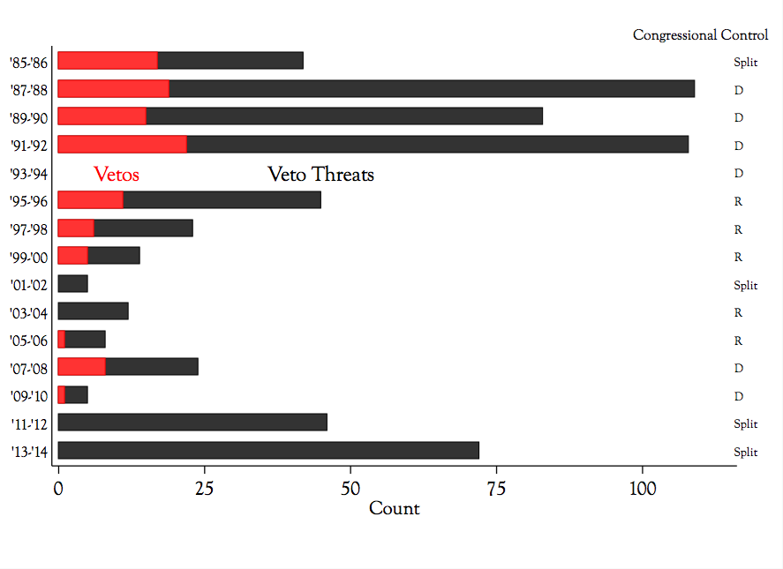
Source: Korte (2015).
Note: Black bars represent the number of veto threats in SAPs and red bars the number of vetoes. There were no threats or vetoes in the 1993-1994.
Table 1.
Example Text of Authorization Provisions and Veto Threats
S 900, The Gramm-Leach-Bliley Act: the House accommodated the Administration by removing the threatened provision, and the President subsequently signed the bill into law. | Provision: (a) In General.—No community financial institution shall be subject to the Community Reinvestment Act of 1977 (12 U.S.C. 2901 et seq.).(b) Definition of Community Financial Institution.--As used in this section, the term ``community financial institution'' means an insured depository institution (as defined in section 3 of the Federal Deposit Insurance Act), that has aggregate assets of not more than $100,000,000, and that is located in a non-metropolitan area. | President's SAP Objection: The CRA exemption for banks with less than $100 million in assets would repeal CRA for approximately 4,000 banks and thrifts that banking agency rules already exempt from CRA paperwork reporting burdens . . . because of [this and other] crucial flaws in the bill, the President has stated that, if the bill were presented to him in its current form, he would veto it.
HR 5104, To Extend the Protect America Act of 2007: the President signed the bill into law despite the lack of accommodation in Congress, which actually reduced the extension from 30 to 15 days. | Provision: Section 6(c) of the Protect America Act of 2007 (Public Law 110–55; 121 Stat. 557; 50 U.S.C. 1803 note) is amended by striking “180 days” and inserting “210 days”. | President’s SAP Objection: H.R. 5104 fails to recognize that the threat posed by al Qaeda will no more expire in 34 days than it will in four days when the PAA expires. Accordingly, if H.R. 5104 were presented to the President, he would veto the bill.
S 1287, Nuclear Waste Policy Amendments Act of 2000: Congress did not accommodate the President, who subsequently vetoed the bill. | Provision: Notwithstanding the time schedule in section 801(a)(1) of the Energy Policy Act of 1992 (42 U.S.C. 10141 note), the Administrator shall not publish or adopt public health and safety standards for the protection of the public from releases from radioactive materials stored or disposed of in the repository at the Yucca Mountain site--(1) except in accordance with this section; and (2) before June 1, 2001. | President’s SAP Objection: Although the amendment appears to allow EPA to exercise its existing authority to set appropriate radiation release standards for the Yucca Mountain repository, it will allow another entity to block EPA's authority until June 1, 2001. Consequently, if the February 4, 2000, manager's amendment to S. 1287 is approved by the Senate and a bill with these provisions is presented to the President, the President will veto the bill.
Table 2.
Likelihood of a Veto Threat
DV: Veto Threat | All Bills | Reported Bills | Enrolled Provisions
Bill Attributes

Introduced in House | 0.335*** | 0.569*** | 1.409**
 | (0.098) | (0.110) | (0.699)
DW Distance from Author to President | -0.002 | -0.014 | 1.435
 | (0.183) | (0.218) | (0.931)
# of Cosponsors | 0.010*** | 0.009*** | 0.002
 | (0.001) | (0.001) | (0.003)
Requested by Agency | -0.218 | 0.275 | 3.395***
 | (0.288) | (0.326) | (0.702)
Author is Com. Chair | 1.057*** | 0.569*** | 0.646
 | (0.090) | (0.102) | (0.535)
Author in Cham. Maj. | 2.219*** | 1.418*** | 0.876
 | (0.215) | (0.251) | (0.693)
>100 Provisions in Bill |  |  | 2.905***
 |  |  | (0.491)
Political Context

Opposition House | 2.303*** | 1.897*** | -1.007
 | (0.472) | (0.487) | (1.066)
Opposition Senate | 0.993*** | 0.923*** | -0.039
 | (0.186) | (0.208) | (0.894)
Divided Congress | -1.153** | -0.768 | 3.325**
 | (0.537) | (0.559) | (1.593)
President Honeymoon | -0.518*** | -0.599*** | -2.870***
 | (0.170) | (0.186) | (1.086)
G.H. Bush | -0.360** | -0.360** | 1.081
 | (0.145) | (0.173) | (0.771)
W. Clinton | -0.555*** | -0.671*** | 0.060
 | (0.128) | (0.147) | (0.731)
G.W. Bush | -0.150 | 0.127 | -0.016
 | (0.129) | (0.145) | (0.897)
Constant | -9.076*** | -6.476*** | -9.267***
 | (0.331) | (0.381) | (1.397)
Observations | 102,483 | 10,984 | 1,420
Pseudo R-squared | 0.146 | 0.132 | 0.350
Log Likelihood | -3214.923 | -1796.818 | -85.27
Robust standard errors in parentheses. Provision estimates clustered on bill.
*** p<0.01, ** p<0.05, * p<0.1

Figure 2.
Legislative Sequences of Veto Threatened Provisions

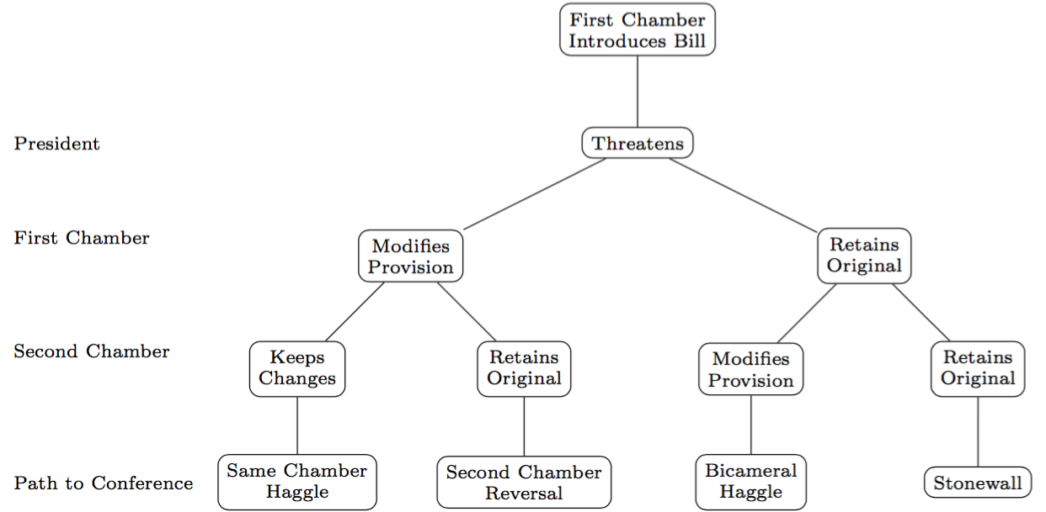

Figure 3.
Distribution of House Rules for Bills

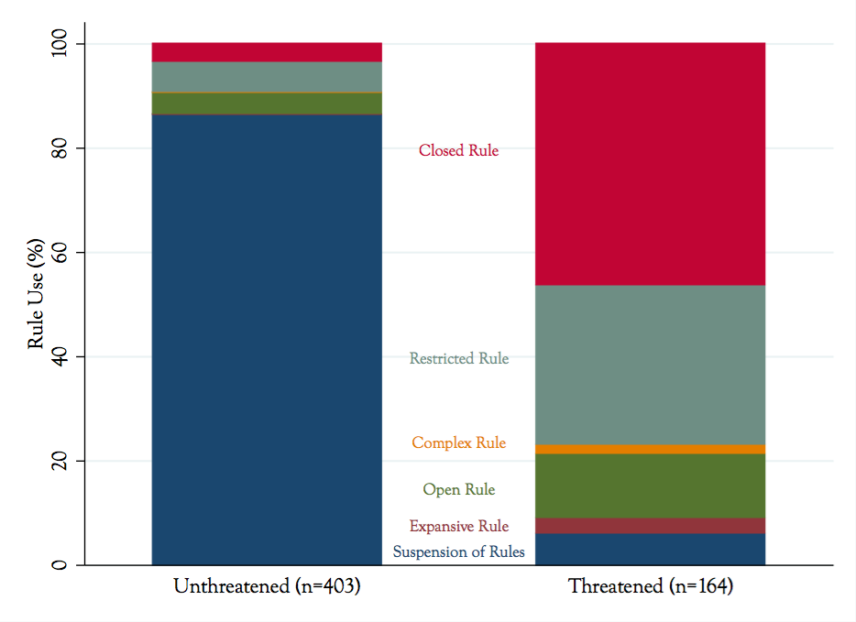Note: The selection of unthreatened House Rules Committee rules presented here is based on genetic match of comparable legislation. Data from 1985 through 2004 were kindly provided by David Owens: we followed his definitions and guidance in extending the series through 2008. See Owens and Wrighton (2007).

Table 3.
Impact of Veto Threat on House Restrictive Rules and Filibuster Threats

 | DV: Restrictive Rules |  |  |  | DV: Filibuster Threats
 | (1) | (2) | (3) | (4) |  | (5) | (6)
All Veto threats | 5.168*** | 3.539*** | 3.428*** | 4.546*** |  | 2.149*** | 2.175***
 | (0.231) | (0.276) | (0.282) | (0.304) |  | (0.339) | (0.351)
“President will veto” threat |  |  | 1.261* |  |  |  | -0.179
 |  |  | (0.765) |  |  |  | (0.550)
Senate Bill | -0.920*** | -0.605* | -0.635** | -0.420 |  | -0.263 | -0.257
 | (0.221) | (0.313) | (0.317) | (0.353) |  | (0.367) | (0.366)
Opposition House | -0.034 | -0.015 | 0.017 | 1.597** |  | 0.585 | 0.580
 | (0.388) | (0.625) | (0.671) | (0.739) |  | (0.951) | (0.953)
Opposition Senate | -0.215 | 0.326 | 0.315 | -0.819 |  | -0.114 | -0.110
 | (0.305) | (0.549) | (0.563) | (0.623) |  | (0.823) | (0.828)
Constant | -3.055*** | -2.163*** | -2.150*** | -7.011*** |  | -4.248*** | -4.262***
 | (0.342) | (0.522) | (0.543) | (0.665) |  | (0.882) | (0.882)
Observations | 5,276 | 582 | 582 | 5,276 |  | 582 | 582
Administration FE | Yes | Yes | Yes | Yes |  | Yes | Yes
Sampling Strategy | Enrolled Bills | Genetic Match | Genetic Match | Enrolled Bills |  | Genetic Match | Genetic Match
Pseudo R-squared | 0.384 | 0.375 | 0.380 | 0.366 |  | 0.171 | 0.171
Log Likelihood | -577.0 | -216.5 | -214.8 | -211.1 |  | -160.6 | -160.5
Standard errors in parentheses
*** p<0.01, ** p<0.05, * p<0.1

Figure 4.
Impact of Veto Threat on House Rules and Filibusters*

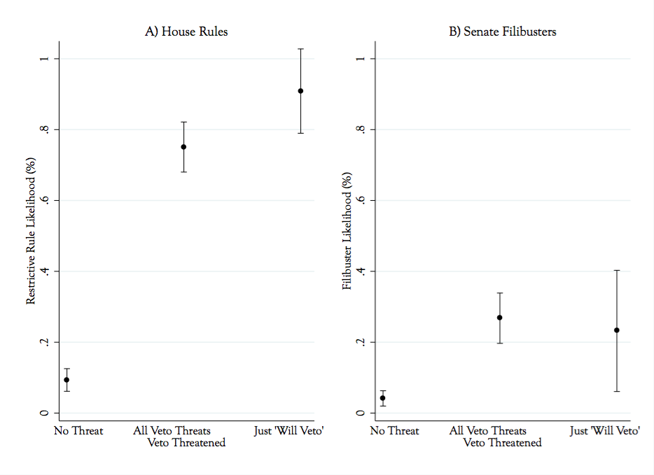
*Based on estimates in equations 3 and 6, Table 3.

Table 4.
Survival of Veto Threatened Provisions by Chamber and Sequence

 | DV: Provision Dropped or Changed by Chamber
 | House |  | Senate
 | (1) | (2) | (3) | (4)
Veto Threat | 1.364*** | 1.104** | 1.681*** | 2.786***
 | (0.462) | (0.502) | (0.558) | (0.614)
Acting 2nd | 0.681** | -0.392 | 0.870** | 1.997**
 | (0.271) | (0.705) | (0.356) | (0.881)
Threat*Acting 2nd |  | 1.272* |  | -1.234
 |  | (0.748) |  | (0.860)
Opposition House | -0.114 | -0.110 | -1.461*** | -1.453***
 | (0.585) | (0.580) | (0.553) | (0.562)
Opposition Senate | -0.046 | -0.039 | 0.600 | 0.581
 | (0.382) | (0.374) | (0.480) | (0.480)
Constant | -1.958*** | -1.730** | -1.662** | -2.677***
 | (0.724) | (0.739) | (0.705) | (0.815)
Observations | 1,088 | 1,088 | 954 | 954
Administration FE | Yes | Yes | Yes | Yes
Sampling Strategy | Genetic Match | Genetic Match | Genetic Match | Genetic Match
Pseudo R-squared | 0.0565 | 0.0609 | 0.101 | 0.103
Log Likelihood | -568.1 | -565.5 | -574.8 | -573.1
Clustered standard errors in parentheses (Clustered on Bill)
*** p<0.01, ** p<0.05, * p<0.1

Figure 5.
Chamber Differences in Response to Veto Threats*
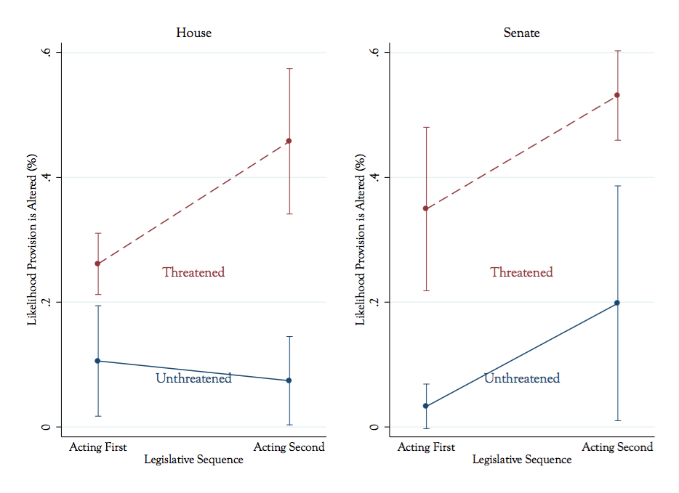
* Based on estimates in equations 2 and 4, Table 3

Table 5.
Share of Threatened Provisions Following Pathways to Conference
Pathway | % of Threatened Provisions
Same Chamber  Haggle | 18
Bicameral  Haggle | 38
Stonewalls | 32
Second Chamber  Reversal | 11

Table 6.
Impact of Veto Threat on Conference Committee Provision Selection
 | DV: Final Provision Amended
 | (1)
Provision Amended in 1st Chamber | -2.122
 | (1.416)
Provision Amended in 2nd Chamber | 0.487
 | (0.487)
1st Chamber * 2nd Chamber | 3.990***
 | (1.521)
Veto Threat | -0.167
 | (0.367)
Amended in 2nd * Veto Threat | 3.035***
 | (0.527)
Amended in 1st * Veto Threat | 4.343***
 | (1.450)
Amended in 1st * Amended in 2nd *Veto Threat | -4.897***
 | (1.578)
Senate Bill | 0.298
 | (0.229)
Opposition House | -0.489
 | (0.518)
Opposition Senate | -1.172***
 | (0.393)
Constant | -0.744*
 | (0.569)
Observations | 1,160
Administration FE | Yes
Sample | Genetic Match
Pseudo R-squared | 0.384
Log Likelihood | -494.3
Clustered standard errors in parentheses (Clustered on Bill)
*** p<0.01, ** p<0.05, * p<0.1

Figure 6.
Impact of Veto Threat and Legislative Sequence on Conference Action*

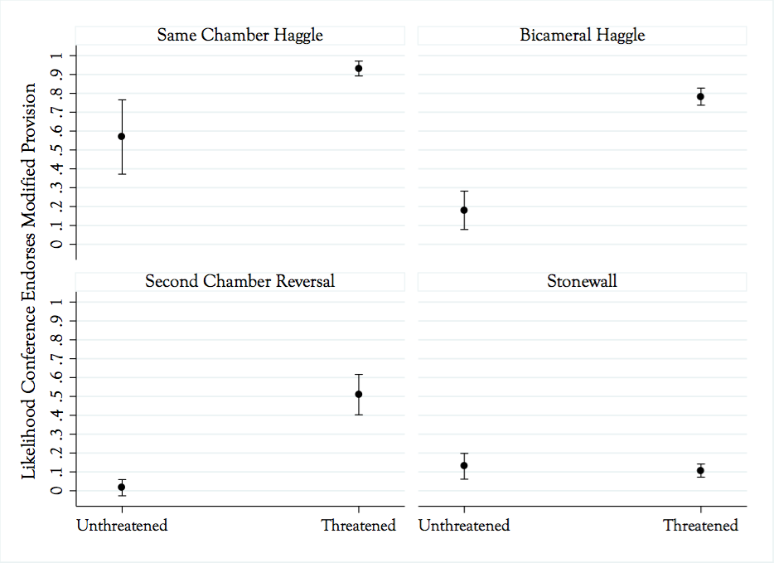
*Probabilities based on estimates in Table 6.
Figure 7.
Presidents’ Veto Action by Share of Accommodated Provisions in Bill
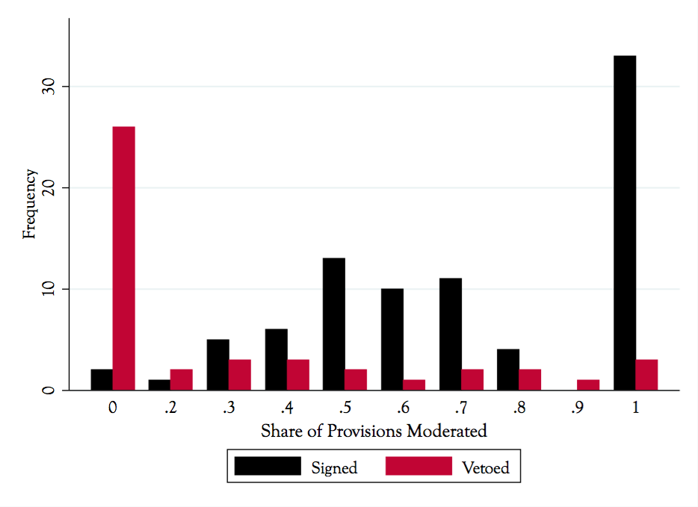
References

Adler, E. S., and Wilkerson, J. (2006). Congressional Bills Project. NSF, 880066, 00880061.
Beckmann, M. N. 2010. Pushing the agenda: Presidential leadership in US lawmaking, 1953–2004. Cambridge University Press.
Cameron, Charles. 2000. Veto Bargaining: Presidents and the Politics of Negative Power. New York: Cambridge University Press.
Cameron, Charles, and Nolan McCarty. 2004. “Models of Vetoes and Veto Bargaining.” Annual Review of Political Science 7: 409-435.
Cox, Gary W., and Mathew D. McCubbins. 1993. Legislative Leviathan: Party Government in the House. Berkeley: University of California Press.
_________. 2005. Setting the Agenda: Responsible Party Government in the U.S. House of Representatives. New York: Cambridge University Press.
Crawford, Vincent P, and Joel Sobel. 1982. “Strategic Information Transmission.” Econometrica 50(6): 1431–1451.
Diamond, A., and Sekhon, J. S. (2013). “Genetic matching for estimating causal effects: A general multivariate matching method for achieving balance in observational studies.” Review of Economics and Statistics, 95(3), 932-945.
Fett, Patrick J. 1992. “Truth in Advertising: The Revelation of Presidential Legislative Priorities.” Western Political Quarterly 45(2): 895–920.
_______. 1994. “Presidential Legislative Priorities and Legislators’ Voting Decisions: An Exploratory Analysis.” Journal of Politics 56(2): 502–512.
Groseclose, Tim and Nolan McCarty. 2001. “The Politics of Blame: Bargaining Before an Audience.” American Journal of Political Science 45(1): 100-119.
Hassell, Hans J.G. and Samuel Kernell. 2015. “Veto Threats and Legislative Riders.” American Journal of Political Science. Early online publication.
Daniel Ho; Kosuke Imai; Gary King; and Elizabeth Stuart (2007), “Matching as Nonparametric Preprocessing for Reducing Model Dependence in Parametric Causal Inference,” Political Analysis 15(3): 199-236.
Ingberman, Daniel, and Dennis Yao. 1991. “Presidential Commitment and the Veto,” American Journal of Political Science 35(2): 357–389.
Jacobson, Gary C. 2015. “How Presidents Shape Their Party's Reputation and Prospects: New Evidence,” Presidential Studies Quarterly 45 (1): 1-28.
Kernell, Samuel. 2005. Presidential Veto Threats in Statements of Administration Policy: 1985-2004. Washington, D.C.: CQ Press.
_______. 2006. Going Public: New Strategies of Presidential Leadership. 4th ed. Washington, D.C.: CQ Press.
Korte, Gregory. 2015. “Is that a threat? White House veto signals often nuanced.” USA Today. January 7.
Krehbiel, Keith. 1998. Pivotal Politics: A Theory of U.S. Lawmaking. Chicago: University of Chicago Press.
Lee, Frances E. 2008. “Dividers, Not Uniters: Presidential Leadership and Senate Partisanship, 1981-2004.” The Journal of Politics 70(04): 914.
Longley, Lawrence D. and Walter J. Oleszek. 1988. Bicameral Politics. New Haven: Yale University Press.
Martin, Andrew D. 2001. “Conressional Decision Making and the Separation of Powers,” American Political Science Review 95(2): 361-378.
Matthews, Steven A. 1989. “Veto Threats: Rhetoric in a Bargaining Game.” Quarterly Journal of Economics 104(2): 347–369.
McCarty, Nolan. 1997. “Presidential Reputation and the Veto.” Economics and Politics 9: 1-27.
Monroe, N. W., and Robinson, G. (2008). “Do Restrictive Rules Produce Nonmedian Outcomes? A Theory with Evidence from the 101st-108th Congresses.” Journal of Politics 70(1), 217-231.
Nather, David. 2006. “White House Attempts to Ease Hill Friction.” CQ Weekly. April 3: 891-892.
Newey, Whitney K. 1987. “Efficient Estimation of Limited Dependent Variable Models with Endogenous Explanatory Variables.” Journal of Econometrics 36(3): 231–250.
Owens, John E. and J.M. Wrighton (2007) “Procedural Control and Majority Party Entrenchment in the U.S. House of Representatives: An Explanation of Rules Restrictiveness Over Time.” Presented to the MWPSA
Rice, Laurie L. 2010. “Statements of Power: Presidential Use of Statements of Administration Policy and Signing Statements in the Legislative Process.” Presidential Studies Quarterly. 40: 686-707.
Rogers, James R. 1998. “Bicameral Sequence: Theory and State Legislative Evidence.” American Journal of Political Science 42(4): 1025-1060.
Rohde, David W. 1991. Parties and Leaders in the Postreform House. Chicago: Chicago University Press.
Schelling, Thomas. 1980. The Strategy of Conflict. Cambridge MA: Harvard University Press.
Schickler, Eric. 2001. Disjointed Pluralism: Institutional Innovation and the Development of the U.S. Congress. Princeton, NJ: Princeton University Press.
Sekhon, Jasjeet, and Mebane, Walter R. (1998). “Genetic optimization using derivatives.” Political Analysis, 7(1), 187-210.
Sinclair, Barbara. 2000. “Hostile Partners: The President, Congress, and Lawmaking in the Partisan 1990s." In Polarized Politics, eds. Jon R. Bond and Richard Fleisher. Washington, D.C.: CQ Press.
Sinclair, Barbara. 2011. Unorthodox Lawmaking: New Legislative Processes in the U.S. Congress. 4th ed. Washington, D.C.: CQ Press.
Taylor, Andrew J., 2008. “Strategic intercameral behavior and the sequence of congressional lawmaking.” American Politics Research, 36(3), pp.451-474.
Wirls, Daniel and Stephen Wirls. 2004. The Invention of the United States Senate. Baltimore: Johns Hopkins University Press.

Cheap talk does allow that “might veto” signals can have a minimal impact on legislation in that such messages convey that the president does not prefer the proposal to any alternative legislation closer to the status quo. This may prompt Congress to shift the proposal’s policy closer to status quo (Matthews 1985).
Senior Clinton legislative affairs aide Patrick Griffin stressed to us that presidents had to be careful to avoid making veto threats that would allow Congress to box them into untenable positions a la Groseclose and McCarty (2001).
McCarty (1997) demonstrates that the reputational costs of presidential messages will vary across presidents’ tenure. Relaxing cheap talk’s non-repeated game stipulation, McCarty allows reputational considerations to enter presidents’ veto rhetoric and legislators’ assessments of the credibility of veto threats. As presidents’ choice horizon shortens, they discount the value of their reputations and begin to issue non-credible threats, and even if not, legislators will suspect them of doing so.
Similarly, fellow partisans in Congress who voted for a bill are significantly more likely to switch their vote to sustain their president’s veto than are the bill’s initial supporters from the other party (Krehbiel 1998).
Such requests were mentioned repeatedly by both Clinton and Bush aides. When asked, “How often did this happen?” one answered, “All the time.” (Interviews with …)
Epstein and O’Halloran (1999) find that the number of committees on which the voting record of the majority party’s median member is an outlier increases with divided government. Outliers’ preferences systematically “tend to move counter to those of the President” (171).
Throughout our discussion, “extreme” and “moderate” represent ideological distance from the president’s policy preferences. In addition to unveiling a bill’s provisions that are in dispute, moving first assures the extreme chamber that its preferences are presented to the other players.
Of course, both chambers might hold extreme preferences with the second chamber proposing an equally extreme bill. Presidents can and occasionally do issue multiple threats at a bill as it wends its way through Congress, allowing us to detect instances of a second extreme bill following a veto threat.
Recent research on the effect of veto threats on the removal of objectionable riders from annual appropriations bills closely follows this sequence. The House Appropriations Committee introduces the great majority of riders that presidents threaten with a veto; the House floor stands firm; the Senate removes sixty percent of the remaining riders and those it cannot act on, it wraps into omnibus bills and punts them to conference; conference then removes a significant share of these threatened riders (Hassell and Kernell 2015). Of course, the House’s Constitutional responsibility for introducing appropriations measures prevents the reverse bicameral sequence.
See the supplementary materials for a distribution of the SAP destinations, and the corresponding number of bills and provisions threatened for each Congress.
Congress frequently and increasingly engages in alternative exercise for resolving differences. These include informal negotiations and ping-ponging bills across chambers to reach uniform language.
For examples of the semantics of SAP-based veto threats, see the supplementary materials.
Personal interview with Patrick Griffin, director of the Clinton White House’s Legislative Affairs office, May 20, 2015.
Although correspondents have rarely referred to SAPs by name over the years, the president’s position on an issue contained in a SAP were routinely reported by both print and network news (Kernell 2005).
Searching JSTOR we find no references to SAPs in scholarship prior to 1995. Even so, scholars have unknowingly employed them in that they served as the primary basis for CQ’s “presidential support score.” In years prior to posting SAPs on its website, OMB routinely faxed copies to CQ Weekly and to other news agencies. Personal interviews with Congressional Quarterly staff in 2006 and 2010.
Below and in the supplementary appendix, we report comparable results for unenrolled bills for bill-level predictions 1A and 1B. Parallel analyses for unenrolled veto threatened provisions would far exceed our resources. We do, however, plan to test the relationships reported below on a matched sample of unenrolled provisions. Here, however, the reported effects of veto threats are confined to shaping legislation that Congress eventually passes.
We first populated the sampling universe for control provisions with only enrolled bills, from which we drew a random sample of 100. Noting that the occurrence of threatened provisions was significantly greater in larger bills, we stratified the sampling probability for bills with greater than and fewer than 100 provisions. For small bills one in four provisions were sampled and for large bills we sampled one in nine.
Choice-based sample weights are calculated by cross-referencing the randomly selected provisions with the list of provisions to identify the common observations. The relative frequency of threatened provisions to unthreatened provisions in the random sample is then used to generate inverse probability weights. We reserve the choice-based sample to make population estimates in Tables 1 and Table 7.
The genetic matching algorithm ran on the following variables: chamber origin of the bill, bill size, bill cosponsor count, committee chair author, ideological distance between bill author and president in DW-Nominate space, first year of presidential tenure, and fixed effects for each administration. The supplementary materials identify the coding procedures and sources of all the variables used in the following analysis.
The genetic matching procedure is a generalization of both propensity score and Mahalanobis distance matching. Estimating all of the reported relationships with the choice-based sample (without matching) yields essentially the same statistical relationships. Results with the Mahalanobis matching and choice-based sample are reported in the supplemental materials.
A full description, sources, and coding rules of the variables employed in the analysis are presented in the supplementary materials. The supplementary materials also report additional tests and robustness checks.
In the 111th Democratic Congress, which lies beyond the period covered in our statistical analysis, President Obama threatened three bills (see Figure 1). George W. Bush is the leading exception to the pattern described here. During the unified Republican 108th and 109th Congresses Bush issued threatening SAPs targeting 20 bills reported out of Republican controlled committees. See supplementary materials for more detailed information about the distribution of SAP-based threats across administrations.
Across the several filibuster measures we tested the results are essentially the same as reported here. We report the alternative filibuster threat specifications in the supplementary materials.
This result differs from the strong relationship for the more emphatic veto threat reported by Hassell and Kernell (2015) for appropriation bills. “Will veto” also failed to generate significantly stronger relationships for the models reported below. We report only the results for the composite veto threat variable.
Note that the “second chamber” estimates in Table 3 omit those provisions already modified or removed by the first chamber. Consequently, the relationships concern the likelihood of the chamber modifying a threatened provision.
The modification rate for threatened provisions is underestimated here, given that we only track substantive changes to the provision that partially or fully respond to the veto threat.
Certainly, conference may seek to restore agreement by splitting the difference between the conflicting provisions. We have scored new legislative language as either moderating the original extreme provision, even if the language is somewhat different from one of the chamber’s modification. To err conservatively against confirming prediction 3A, we have scored ambiguous changes in text as conference retention of the original, “extreme” provision.
Refer to Figure 2 for a diagram of all the possible revision patterns.
The real anomaly here, and the only one in this exercise, is the miserable success of the second chamber when it reverses the first chamber’s modifications of its own original proposals. We do not have an explanation for this.

