February 28th
Natalie Schenker
Postdoctoral Researcher, The Brain Observatory, UCSD School of Medicine
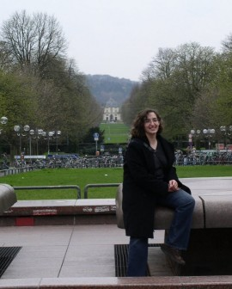
“Broca’s area: a perspective from the Digital Brain Library”

The Digital Brain Library project is a unique effort to compare what has been learned about human behavior and neurological disease with the actual organ, the brain. Over the next decade, the challenge is to archive the brains and personal profiles of as many as one thousand participants. The result will be a thousand portraits that combine anatomical detail with medical and personal histories. Our motivation is simple: if we create a large enough neurological collection that can be explored and visualized in unprecedented ways, then we can hope to glimpse at the fundamental features of the human brain and to decipher individual patterns of maturation and disease.

Traditional brain banks consist of anonymous specimens labeled with specific diseases that are analyzed in pieces by extracting and distributing partial samples to investigators. Although this is an economical and efficient process, it is ‘destructive’ in that it is impossible to reconstruct the complete anatomical profile of each brain in its entirety. Due to unique technology innovated by the UC San Diego Brain Observatory, we can now transform a brain into a complete collection of detailed images that can be visualized at very high resolution, reassembled into 3-D models, and studied with virtual tools, without compromising the brain’s original integrity.

Broca’s area is an area of significant interest both for the study of disease, such as aphasia, and for understanding normal variation of the anatomy of language. Here I present a brief history of the study of the region and demonstrate how the Digital Brain Library can be used to cultivate and facilitate this type of research.

