Day1 (Chapter 1, etc…)

I was reading in chapter one about different ways visual stimuli enter the brain through partial decussation. I found this neat illusion online and was wondering, why the cat can spin both ways? Does this mean that one part of our optic nerves is delivering more information than the other? Or do some regions of the brain work "harder" than the others to make it spin a certain way? Or perhaps is it heuristics and what we are accustomed to seeing? For example, if we made a lot of left turns this morning driving to school does it affect which way the cat spins? Sorry for the lengthy email.
https://www.youtube.com/watch?v=KtSHsMTFfVg –Dominic

A Discussion figure explaining this, from Shai Azoulai’s Ph.D dissertation:

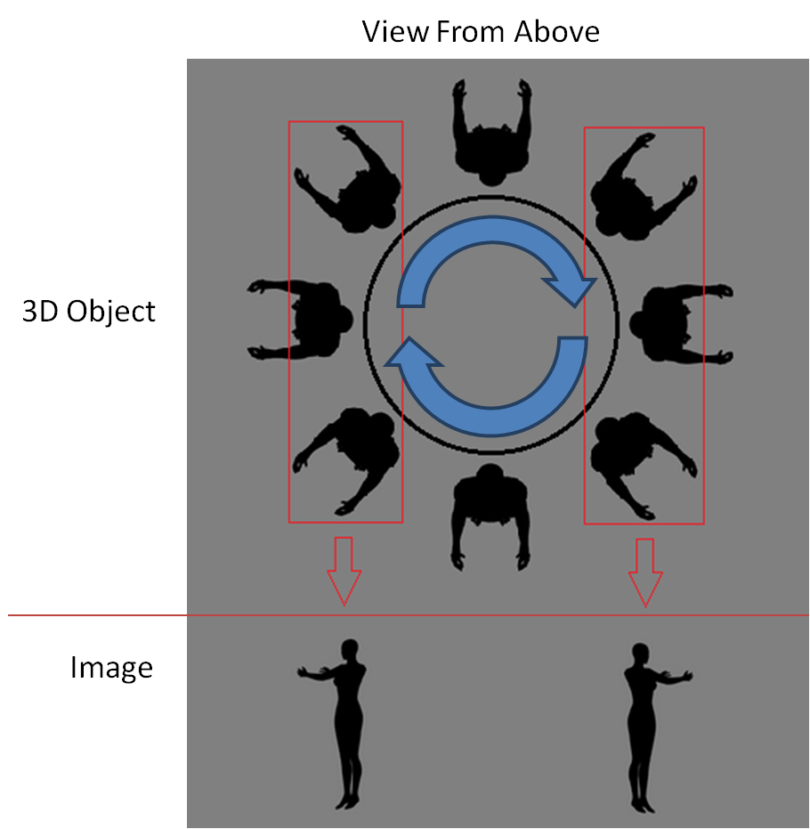

From the book "we agree with Marr-understanding brain structures must include an understanding the nature of the computational problems entailed in seeing...only when we understand how those problems can be solved in principle will we fully grasp why brain structures have the properties that they do" (Frisby & Stone 53). An issue with this statement is what happens if no computational framework exists that describes a particular problem in vision? If no such framework exists are we doomed to never fully understand that visual process or the properties of the brain structures involved in it? -Oscar

Here is an interesting link about Neil Harbisson, the colorblind person we were discussing briefly last Thursday. He can hear color through the antenna implanted in his skull! –Punit https://www.ted.com/speakers/neil_harbisson
Here is an interesting article I found online that contrasts the differences between how our eyes view images as opposed to cameras. Figure 1.7 reminded me of an inverse film projector that project onto hypercolumns. "Our eyes are not cameras. Instead, they track onto objects and receive a continuous flow of photons onto the retina, sending information via a chemical reaction to the brain." -Michael Stevens from a Youtube series.
http://nofilmschool.com/2014/03/do-human-eyes-see-like-cameras-resolution-frame-rate-of-vision
-Alexander Gilburd
I have a question with the origin of perception. There are several theories saying either perception is acquired through learning or it is innate. But if it is learned, how do we know the way to classify such information put in our brains? And if it is innate, how do we process to know that what we learned fits to the mechanism we already have? –Emily

Mike May
-Why is it that Mike May cannot identity things in 3-D orientation but can use motion cues to create a 3-D shape? -Julie
My question after reading the paper is whether the ability of the superior colliculus in guiding orienting behaviours remained relatively intact, since the pathway seems to be part of an “older” system and generally remains intact even in cortically blind patients? -Priscilla
From the paper, subject MM recovers certain perceptual functions close to perfection while some remains damaged after treatment. What might this suggest about how our visual system develops at an early age? -John
This web article chronicles the life and times of Michael May. Of particular interest is his reaction to receiving a corneal transplant at the age of 46 after having blind since he was 3. He seemed to start experiencing various difficulties and it seemed to almost limit him in some aspects, since he had grown accustomed to navigating this world under certain criteria. -Alexander
May still travels with his dog, Josh, or taps the sidewalkwith a cane, and refers to himself as "a blind man with vision." http://discovermagazine.com/2002/jun/featsight
here's a viral video about this interesting piece of equipment called "eSight Glasses" that allowed this woman to see for the first time! https://www.youtube.com/watch?v=e9crPvfcEy4 –Punit
Don Hoffman’s “Interface Theory”
Bayes’Theorem:
Just to recap what I read on the Hoffman Interface paper; things we see are not objective world reconstructions, rather user specific interface constructions?
I found page 16 to be pretty fascinating. Math was applied to real life events such as the probability of user interface events to be informative about real world events. I was wondering if you had a brief explanation of what this means? Or how scientists come up with such formulas? -Dominic
Good general account of the logic of Bayes’ Theorem: http://www.yudkowsky.net/rational/bayes Don

I found this article initially searching for web articles clarifying how Bayes Theorem can be used for various other aspects of vision. In this article, it shows how the theorem can be used to rationalize the precepts elicited by a specific visual stimulus by using examples functions of luminance and reflectance. It also contrasts Bayes theorem to the Empirical Ranking theory. ''In sum, Bayesian decision theory in its basic application determines the physical source(s) capable of generating a given retinal image and the relative probabilities of their actually having done so; the percepts predicted are therefore explicit models of world structure." http://www.purveslab.net/research/primer.html -Alex *This is an interesting web article, and it may deserve detailed presentation/discussion, perhaps when we talk about lightness. Don
1) Hoffman assumes this argument from evolution : " that natural selection rewards true perceptions" and uses it as a basis for his theory making some contradiction to this. I haven't ever seen the concept phrased in his way, but am instead more familiar with and more readily subscribe to the idea that natural selection favors those perceptions which are most helpful ( in terms of survival and reproduction) to the system. Is Hoffman assuming too much or am I?
2) Hoffman's point about perceptual experiences providing niche specific properties to whatever organism is in question to me is a valid, but not completely revolutionary point. The idea that our perceptual world is but a construction based on our umwelt (environmental landscape which we are privy to) has been implied if not directly discussed in much of the perception literature. So, Hoffman's big contribution is this notion that any "true" object property is "mowed down" by the brain, which instead opts for the preferred interface relevant to that organism. I agree that "true" perceptions aren't always helpful - and that we construct the most the most helpful model in our species specific interface, but I also have trouble with this idea that anything close to "truth" is tossed away. On some level, some "true" values corresponding with some aspect of reality are processed, but are not represented in consciousness ( not present in our "Phenomenal Self Model") and therefore not perceived. However, our perceptions are necessarily preceded and governed by this earlier information making the end result, the conscious representation - a model of sorts which does have some truth ( in terms of corresponding with some aspect of external reality. ) –Zeve
Superstimuli and Effective Fakes:
Since humans have higher intelligence than jewel beetles and herring gulls, I was wondering if humans have more diverse supernormal stimuli that affects us? What constitutes as supernormal stimuli for us and we can't possibly have only one or two right? I found this article that somewhat answers my question but I was wondering if it can be elaborated? http://lifehacker.com/supernormal-stimuli-is-your-brain-built-for-porn-junk-1575846913 -Julie
We compared the beetles and their beer bottles to pornography and how it is unrealistic to be aroused by a piece of paper as it is by a bottle if you're a beetle. In each case, wouldn't the retinal image being processed still be the same (or very similar) as an actual beetle or human mate? The difference is that as humans we have the cognitive ability to know that we are merely looking at a piece if paper whereas the beetles actually believes the bottle is a beetle. How does this element of cognition play into our perception? If we know we are being deceived, but have a physiological response regardless, what does that say? –Anon Perhaps in such cases we are giving up cognitive control, or abandoning rationality? Don
I am not certain if I understand the paper correctly, but the impression I got was that our perception of the world needs not bear any resemblance to the objective reality, and may be completely arbitrary in a sense that it just happens to be the most adaptive way for us to experience the world. I was wondering what this entails for artificial intelligence, since one of the arguments against sentience in robots, even robots who are able to pass the Turing Test (I don’t think there are any at the moment) are that they do not experience qualia. However, computers have a completely different biological makeup than we do, and thus the interface that may be beneficial for their “survival” may be completely different from humans. Perhaps their perception of the world is most adaptive when everything is represented by 1s and 0s. If so, would it be possible to say that some computers may already be capable of perception? –Priscilla But also: what would make it matter whether they have qualia or not? Don
Do you think that eventually sometime in the future the human eye will evolve to the point where our blind spot is removed? Or do you think that because our eyes can see enough to survive, evolution to remove the blind spot will not occur? –Daniel
An article on how colorblindness could have been evolutionarily advantageous at one point. http://www.nature.com/news/2005/051205/full/news051205-1.html Thought it’d be interesting to talk about in the light of Don Hoffman’s paper. –John In the cited experiments, the conditions are rather artificially chosen to give an advantage to the color ‘anomalous’. Compare: wartime attempts to use color-anomalous people to penetrate camouflage…Don
Here's an interesting video regarding our current evolution. I couldn't find anything too great regarding the evolution of our eyes but this video addresses proof that we are still evolving, which is fairly obvious but some people in the world don't believe in it at all! https://www.youtube.com/watch?v=MRpCo2f6Ew4 Interesting evidence of genetic drift in human populations over a few thousand years.
here's another link to an abstract (short and sweet) covering the evolution of color patterns in animal visual systems: http://www.ncbi.nlm.nih.gov/pubmed/16329248 -Punit Interesting but technical: compare co-evolution of colored fruit with primate red/green color vision (e.g. Mollon and Regan)

Chapter 2: Shape from Texture, an ‘inverse problem’
(CH 2) Another thing that is almost like an illusion to our eye is with detailed street chalk art. Instead of being a trick for the eye, it is rather using depth, texture, and color cues to mimic something that is familiar to our eye, making us believe it is really there. http://www.buzzfeed.com/ariellecalderon/brain-melting-works-of-3-d-sidewalk-chalk-art#.tanrjjekP –Erika
Great link: Also, http://www.anopticalillusion.com/2013/11/honda-cr-v-optical-illusion-commercial/
I was wondering why we see ellipses as slanted surfaces on a sheet of paper instead of the actual shape itself? –Dominic
I had a hard time what Chapter 2 was trying to get at with finding p and q texture density and this link on the Ponzo Illusion helped me understand a bit on what q is: http://psychology.about.com/od/sensationandperception/ig/Optical-Illusions/The-Ponzo-Illusion.htm
Tilt around horizontal and slant around vertical…
I understand that anisotropy deals with the orientation of optical properties but can you explain to what makes certain materials anisotropic. I googled materials that are anisotropic but I still don't see strong links between the different materials that are that way. –Julie Anything that develops under anisotropic influences, notably gravity (wood grain and branching of trees, strata of rock faces)
Here is an interesting article I found that gives a step by step instruction on how to make a home-made pinhole camera using a can of Pringles chips. "This kind of camera is called a camera obscura-which is Latin for 'dark chamber'." http://www.exploratorium.edu/science_explorer/pringles_pinhole.html -Alexander Note, Optimal pupil diameter for trading off blur against diffraction...
Why is it that bistable/unstable images get perceptual flipping, but images like mooney faces or the camouflaged dalmation get a perceptual clicking that is seemingly irrevocable. I ask because although the dalmation image is in fact camoflaging a dalmation, might there perhaps be a way of generating the image so that it is ambiguous enough to get a similar flipping between possible perceptual 'hypotheses", or is there something fundamentally different outside of the notion of ambiguity that drive the irrevocable perception of the dog. –Zeve (1) Compare scientific theories: a good alternative must be available before the existing view can be abandoned. (2) Are perceptual schemas indestructible once built? Don
My question is what would happen when there are conflicting cues of depth? Apart from texture, other cues may also indicate depth, such as converging lines. Say there is a picture in which the edges of a road converge towards the horizon, but the bricks of the road remain the same size throughout, which cue would “win out” (i.e. would the road be perceived as a patterned, 2D trapezium or a road with weirdly shaped bricks extending out from the perceiver)? Priscilla Ames room example too Don
I had one more question before we abandon chapter two. Marr’s theory, is he theorizing a process of vision to everything? Biological and artificial? I found the third step, the hardware step kind of vague. How does the hardware mediate shape from texture? How do we do all of this math converting (p,q) into (slant, tilt) without using neural resources? Has human vision become a form of multitasking that has become second nature to us in a way? Dominic
I found this interesting article online about a fairly new retinal implant that is helping to restore vision in patients the world over. 'What is really exciting is that the implant also seems to be stimulating the retina around it. So there is functional improvement there, too."-Alexander http://www.dailymail.co.uk/health/article-138886/Robot-eye-restore-lost-sight-20-years.html Early days: ew patients, crude vision, some benefit, read 1 letter/navigation possible…Don
I have included an interesting perception illusion, the monkey business illusion. I'm sure all the classmates would know about this but this one has a bit more advanced illusion. https://www.youtube.com/watch?v=IGQmdoK_ZfY Emily
I thought this website to be very interesting, it is a link to a book which teaches about improvements to make as a photographer. This particular section of photo submissions is surrounding the idea of texture, and how different lighting angle on the area being photographed can create the perception of differing textures. http://seeingfresh.com/assignment-index/texture?page=1 -Erika

Chapter 3
page 59. Could the micro electrode inserted cause stimulation of the nerve cells or is it to small to have any effect? How do we know the insertion of the micro electrode isn't the cause of stimulation? –Natida
I thought I understood what template matching was in Chapter 3 but when it went into 18 templates and combinatorial explosion, it really confused me. I understand that single cells contain only 18-20 different orientations in the retina so why is it that we achieve 5,832 to 1,889,568 templates. I read something about finding suitable template for size but I still don't understand. -Julie
Here is an interesting research article found on research involving how various drugs were shown to affect various changes in the functioning of receptive fields in monkeys. https://vpl.usc.edu/files/2013/07/McMohonetal2004.pdf -Alexander McMahon, surrounds not GABA mediated, so not from horizontal cells but from inner retina…good but technical
Here's an interesting abstract for an article titled "Two-dimensional spectral analysis of cortical receptive field profiles." I didn't understand it nearly as well as I should have but I'm sure it will peak your interest! http://www.sciencedirect.com/science/article/pii/0042698980900656 -Punit
When we visually scan through a scene, our eyes are constantly making jerky saccadic movements, and the image will fall on a different part of the retina every time the fixation of the eyes change. This means that the input from receptors to the simple cells (and complex cells) will constantly be changing, which leads to fluctuating activation (e.g. an ‘edge detector' with horizontal inhibitory/excitatory receptive fields may be momentarily inhibited or excited if the eyes move up or down). However, when we perceive objects, we do not see flickering or shifting edges. How does the visual system manage to compensate for eye movements? And does the correction occur more downstream (e.g. combining info from multiple neurons during object recognition) or upstream (e.g. immediately correcting for eye movements using interoceptive cues from eye muscles, etc)? –Priscilla
Here is a video of a presentation by Brian Russ, a researcher who specializes in researching vision processing in Macaque monkeys. Of particular interest are the high response rates for facial stimuli and motion stimuli in certain parts of their brain. Apparently, even showing the monkeys movies of disasters, which contained a high degree of motion from "biological motion," produced high response rates which they measured with fMRI. https://www.youtube.com/watch?v=9Ll3tdv-CYM -Alex
My question is about a definition in chapter 3. I've heard two slightly different definitions of "receptive field". Professor Sammartino and the book have a similar definition-- that the receptive field, for vision, is a patch on the retina. However, I remember professor Dobkins saying that the receptive field is a point out in space that enervates a receptive cell. These are slightly, maybe even trivially, different. Is there some variation in this definition? Or is there a more correct one? -Anon
The section of Chapter 3 discussing "orientation tuning" explains that different orientations of objects are "dealth with" by different cells. If a patch of cells tuned to deal with a certain orientation were somehow destroyed, what would happen when we saw objects in the orientation that those cells dealt with? Would it make it impossible or more difficult to process stimulus from objects in that specific orientation? -Anon
Chapter 4: Aftereffects, the Psychophysicist’s Microelectrode
How would you conduct an experiment to prove that we use either population or local coding for feature representation? Emma
- Chapter 5, Seeing Edges
Can you explain to me the process of laplacian receptive fields. I can't seem to comprehend how this works at all. Are we supposed to be responding to the stimuli in the center or the spinning of the set of weights? Can you give an example of a laplacian receptive field? –Julie
Frisby mentions the concept of block portraits and the fact that human with perfect vision have to squint to actually be able to see the image. Does this mean that people who need glasses would see the block portrait perfectly without glasses? How would Mike May see block portraits? (p. 129-131)

This is a brief section of an interview with Noam Chomsky discussing Marr's Computational Theory and how it may explain things like the brain's system, but not necessarily all biological systems, such as the immune system. "You begin by studying the system abstracted from what you plausibly take to be irrelevant intrusions, see if you can find it's basic nature, and see what happens when you bring in [other stuff.]" https://www.youtube.com/watch?v=qAuctNYGNm0 The full article in The Atlantic if you're interested. http://www.theatlantic.com/technology/archive/2012/11/noam-chomsky-on-where-artificial-intelligence-went-wrong/261637/ -Don
My general question about this chapter is: at what stage in the visual system does edge smoothing happen? Does it happen in V1, or is this before even that stage? –Anon
Here are five optical illusions that would make most people question everything! I've covered a few in my presentation =) https://www.youtube.com/watch?v=QTC-0F3gJhQ -Punit

Ch. 6: After briefly reading about the periphery effect I was able to find an illusion that was an excellent example of the effect called the peripheral drift illusion. Here is a link explaining what it is and how it works. http://www.psy.ritsumei.ac.jp/~akitaoka/PDrift.pdf -Julie

I was reading Ch. 6 and it proposed an interesting mystery. What does the periphery effect possibly imply about the evolution of the retina? -Alexander

Chapter 6, The Retina
Our simple cells respond are excitatory or inhibitory with regards to location on the receptive field. Pattern of light optimally shaped as a bar stimulates these simple cells. Orientation and edge detection also stimulates these cells. I guess what I am still confused on is how do these cells choose to be inhibitory or excitatory in certain locations? If there are predetermined areas that will excite/inhibit how do the simple cells randomly develop their characteristics. -Dominic

I was reading Ch. 6 and it proposed an interesting mystery. What does the periphery effect possibly imply about the evolution of the retina? -Alexander

From what I've heard in other perception classes, the edge information seems to be the same in both the retina and V1. However, the signal makes a stop at the LGN. Is there any research that implies that the LGN does any computation? Or is the LGN mainly considered a relay station? -Anon
Hi! Here's a YouTube link for temporarily experiencing visual dyslexia (scotopic sensitivity).
https://www.youtube.com/watch?v=D5seJ_PbKMY -Punit

Chapter 7, Figure and Ground
Ch.7: After reading the concepts of this chapter, it reminded me a lot of how photo mosaics are an example of Gestalt's grouping principles. In photo mosaics random tiny pictures are carefully fixated together to form a whole separate picture.
Some examples:
http://www.picturemosaics.com/concepts/ http://images4.fanpop.com/image/photos/22200000/COOL-Johnny-Depp-face-Jack-Sparrow-mosaic-johnny-depp-22259166-754-850.jpg
http://devitry.com/2202.png -Julie

Compare Arcimboldo, Navon, Palmer, ambiguous figures

Chapter 8, Object Perception
Here is an advertising video about a software program called Qualcomm Vuforia 4.0 that allows developers to use the principles of 3D object recognition to help them scan objects in order to keep track of their 3D features including movement. This particular advertisement is for the Beta Development Kit.
https://www.youtube.com/watch?v=EXZF_VRBVk0 -Alexander Gilburd

Chapter 9, Brain Cells
Chapter 10, Brain Maps

Chapter 11 Seeing and Complexity Theory 255
Chapter 12 Seeing and Psychophysics 281

Week 9 Thursday May 22: brief presentations based on your papers
Chapter 13 Seeing as Inference 307
In regards to chapter 13, how does "prior probability" interact with situations where we see things in a scene that aren't actually there? Like seeing shapes in a cloud, or objects in a rorshach test? Wouldn't our prior experiences lower the likelihood of our perception of seeing a rabbit (for example) in a blotch of ink?
While Bayes' Rule makes sense both logically and behaviorally (and evolutionarily for that matter) I am still a little confused on the neural underpinnings of its implementation. It seems that figure 13.12 on page 319 partially references a sort of long term potentiation. Is long term potentiation the neuronal implementation of Bayes' rule? –Shannon
On page 314 an illustration of Bayes' Rule shows the retinal image as "likelihood" and "prior probability" as past visual experience both combining to form the "posterior probability." This is consistent with the idea of the feedback loop at the lgn and the fact that Mike May had trouble perceiving his restored visual information because he has no prior probability. Is it possible to induce a Mike May style of vision in a healthy volunteer by using transmagnetic stimulation on an area within the brain that is responsible for past visual experience?
In Chapter 13, the author refers to reality, virtual reality, and demons (p. 309-311). The situation that he proposes talks about a hot air balloon, different worlds, and demon creatures. Is there a better way to visualize this concept, because this seems confusing to me? -Lina

Week 10 Tuesday May 27:
Chapter 14 Seeing Motion, Part I 325

I'm a bit confused about the aperature problem. If there are two directions of motion being detected across the retina, it creates two different direction patterns of activations across the photoreceptors, but combines the two of them to create a global perception of motion? Am I understanding this correctly? –Emma

I have a question about chapter #14, my question is really just fundamental and about the structure of the detection of motion on just the neuronal level, I understand the idea of an "And" gate and a DR as a unit that has a preferred direction, but I'm confused on the hierarchy of the structure itself. and if the information is collected across a receptive field which then causes the excitation or inhibition of the AND gate cell which further down in the hierarchy causes the excitation or inhibition of a DR or DL? or is the chain of events as I've listed them not quite on point? -Christina
What does "blind sight" tell us about motion perception in vision? -Devin

Chapter 15 Seeing Motion, Part II 355

Week 10 Thursday May 29:
Chapter 16 Seeing Black, Gray, and White 373

Week 9 Tuesday May 24:
Chapter 17 Seeing Color 397
For the seeing color chapter my quandry is on the opponent color theory. I was thinking about how red-green are opponents and blue and yellow ( a sum of red and green) are opponents. Do you think that blue does not have a single source color opponent: perceived color X. do you think we don't have another grouping for color X due to human limitation or because there isn't a color X out there in the world? If we did see more than just RGB on the electromagnetic spectrum, do you think blue would be paired with something else? Just kind of letting my imagination run on this one. -Emma

Week 9 Thursday May 26:
Chapter 18 Seeing with Two Eyes, Part I 419

Chapter 19 Seeing with Two Eyes, Part II 465

Week 10 Tuesday June 3: The Symbolic Representation and its Computation
Reading: Chapter 20 Seeing by Combining Cues 497

Chapter 21 Seeing in the Blocks World 511

Week 10 Thursday June 5: Perception as a constructive process; Review /Patrick Cavanagh colloquium
Reading: Chapter 22 Seeing and Consciousness 527

Chapter 23 Seeing Summarized 539

********
I came across this video that shows water reacting to a 24 Hz sine wave. I thought it might tie into what Lee Ann was talking about with her presentation.
http://www.iflscience.com/physics/sound-water-and-camera-make-zigzag-awesome - pretty cool!

As I was driving to campus this morning, NPR did a segment on this thing called EyeWire. A researcher at MIT created this "videogame" for gamers to help identify neurons in a retinal slice. It turns out that humans are better than AI at identifying and completing pieces that make up a neuron - it's kind of like a coloring book. This data gets used to create a neuronal projection to the brain. I believe what I heard on the radio was that what they've discovered through this is an ability to detect motion at a retinal level (I need to double check that).
Here's a link to EyeWire's blog: http://blog.eyewire.org/ where you can also link to the game if you're interested. I think it's a pretty innovative way to collect data, and tried my hand at identifying a few neurons! Emma
http://blog.eyewire.org/image-gallery-eyewires-first-nature-paper/,
http://blog.eyewire.org/eyewires-first-scientific-discovery-and-nature-paper/

