March 7th
Gabriela Caballero
Assistant Professor, Dept of Linguistics, UCSD
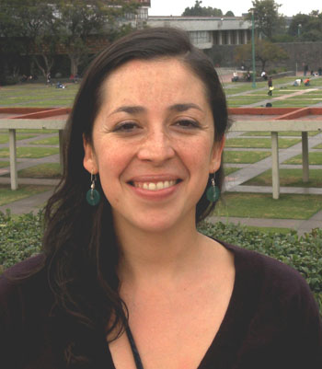
“Documenting word prosody in Choguita Rarámuri (Tarahumara)”

Growing research on the sound systems of endangered and understudied languages allows us to have a better understanding of what are possible sound systems in human languages, but comprehensive descriptions of the sound patterns of little-known languages are still largely missing. Specifically, studies on word prosody and its interaction with intonation have been largely neglected in descriptive studies. This talk reports on ongoing research that seeks to fill this gap by investigating the distributional properties and acoustic correlates of word prosody in Choguita Rarámuri (Tarahumara) and the interaction between word prosody and intonation in this Uto-Aztecan language. Choguita Rarámuri exhibits both phonetic and phonological properties of stress systems. In addition to stress, Choguita Rarámuri possesses a tonal system. While the development of tonal contrasts has been documented for a number of related languages, no variety of Rarámuri has been ever described as featuring contrastive tone. In addition to providing the first comprehensive description of the interaction between stress, tone and intonation in this language, this research project seeks to eventually determine the degree to which age and gender differences of speakers might condition variation in production and perception of these properties. This talk addresses analytical and methodological implications of conducting this research within the context of a larger documentation project.

